Health History Questionnaire

All questions contained in the questionnaire are strictly confidential and will become part of your medical record.

**NAME**: __________________________________________________**DATE**: ________

**Date of Birth:** ______________________________________

**Gender**: MALE FEMALE

**Referred by**: Doctor Friend Previous Patient Other: _____________________

**Marital Status**: Single Married Divorced Widowed

**Children:** NO YES

If yes, number of children? _________________________

**Occupation**: ________________________________

**Religious preference**: ___________________________________________________

Please indicate if you believe any of the items listed below will interfere with your ability to learn about your condition(s) or medication(s):

___No difficulties

___I cannot hear well enough to receive verbal information

___I cannot see well enough to read printed information

___I do not speak English well

___I do not read English well

___I have trouble remembering things

___Other, please specify: ____________________________________________

Is there someone needed to interpret for you? No Yes

How do you prefer to learn? Oral instruction Written instruction Demonstration

**Social History**

Please check those applicable to you:

**Exercise**: None Occasional Regular Vigorous

Type of Exercise: ____________________________________________________________

**Nutrition:**

Any dietary restrictions either self-imposed or recommended by a professional? _______________

_______________________________________________________________________________

What do you eat typically for

Breakfast: __________________________________________________________________

Lunch: _____________________________________________________________________

Dinner: _____________________________________________________________________

Snack: _____________________________________________________________________

Alcohol intake: None Occasional Weekly

How many drinks per week? ___________________________

Are you concerned about the amount of alcohol you consume? No Yes

Tobacco intake: Cigarettes Vape Cigars Pipe Snuff/Dip

How much do you smoke/snuff daily? ______________________________________________

Have you tried to quit? _____________________________ Quit for how long? _________________

Relapsed? ________________________________

Would you like to quit? No Yes

Do you currently use recreational or street drugs? No Yes

If so, what do you use_________________________________________________________________

How often? _________________________________________________________________________

Would you like to quit? No Yes

Do you live alone? No Yes

If no, whom do you live with? ___________________________________________________________

Do you want Magnolia Family Medicine to leave messages regarding your test results, appointments, or other medical communications with the person you live with?

No Yes

|  |
| --- |
| What is your preference of contact? |
| At your home: Yes No Phone Number |
| At your work: Yes No Phone Number |
| Cell phone: Yes No Phone Number |

Do you have Advanced Directives? No Yes

Do you have any questions about Advanced Directives? No Yes

Would you like information about Advanced Directives? No Yes

Do you have a Power of Attorney? No Yes

**Family Medical History**

Please list any significant health problems of parents, siblings, children.

If deceased, please not their age at the time of their passing.

|  |  |
| --- | --- |
| Mother Alive Age | Disease(s) |
| Father Alive Age | Disease(s): |
|  |  |
|  |  |
|  |  |
|  |  |
|  |  |

**Medications**

Please list all medications both prescribed and over the counter. If you need more room to document, please write on the back side of this form.

|  |  |
| --- | --- |
| Medication | Dose/Frequency |
|  |  |
|  |  |
|  |  |
|  |  |
|  |  |
|  |  |
|  |  |

Any ALLERGIES to medications/foods/metals? No Yes

If yes, what allergies? ___________________________________________________________________________

**Medical History.**

Please check the box for all that apply

|  |  |  |  |  |  |  |  |
| --- | --- | --- | --- | --- | --- | --- | --- |
| **Skin**  Yes  Ex: Rashes  Lesions | No | **Eyes**  Yes No  Ex: Eye pain/burning Loss of vision Double vision | | **Constitutional**  Yes No  Ex: Fever  Weight gain/loss | | **Chest/Heart**  Yes No  Ex: Chest pain Palpitations | **Neurological**  Yes No  Ex: Memory changes Difficulty walking Slurred speech |
| **Genitourinary**  Yes No  Ex: Urinary frequency Burning with urination Sexual function problems | | **Throat**  Yes Ex: Sore throat | No | **Head/Neck**  Yes  Ex: Neck pain Headaches | No | **Back**  Yes No Ex: Low back pain | **Endocrine**  Yes No  Ex: Excessive thirst Cold/heat intolerance |
| **Gastrointestinal**  Yes No | | **Hematological**  Yes No | | **Psychiatric**  Yes | No | **Lungs**  Yes No  Ex: Cough Shortness of breath | **Ears/Nose**  Yes No |
| Ex: Abdominal pain Nausea/vomiting Rectal bleeding | | Ex: Easy brusing Easy bleeding  Lymph node swelling | | Ex: Depression Anxiety Psychosis |  | Ex: Hearing loss Ringing  Nose bleeding |

**Past surgeries:**

|  |  |
| --- | --- |
| Type of Surgery | Approximate Date of Surgery |
|  |  |
|  |  |
|  |  |
|  |  |
|  |  |
|  |  |

Have you ever needed a blood transfusion? No Yes

If yes, what year did you receive a transfusion? _____________________________________

**Mental Health:**

Is stress a major problem for you? No Yes

Do you feel depressed? No Yes

Have you ever attempted suicide? No Yes

Do you have trouble sleeping? No Yes

Do you have thoughts that you are better off dead? No Yes

**Chronic Pain:**

Any falls in the last six months? No Yes

Please rate pain level in each area of the body on a scale of 0-10, with 0 being NO pain and 10 being UNBEARABLE pain.

Headache 0 1 2 3 4 5 6 7 8 9 10

Neck 0 1 2 3 4 5 6 7 8 9 10

Right arm 0 1 2 3 4 5 6 7 8 9 10

Left arm 0 1 2 3 4 5 6 7 8 9 10

Back 0 1 2 3 4 5 6 7 8 9 10

Right leg 0 1 2 3 4 5 6 7 8 9 10

Left leg 0 1 2 3 4 5 6 7 8 9 10

Stomach 0 1 2 3 4 5 6 7 8 9 10

Other: _____________________________________________________________

Date of most recent colonoscopy? ____________________________________________

History of polyps? No Yes

History of colon cancer? No Yes

History of any cancers in the past? No Yes

If yes, what type of cancer? ____________________________________________________

How many years in remission? _________________________________________________

What treatment did you receive as treatment for the cancer? __________________________

History of injuries such as fractures? Crush injuries? No Yes

Date of injury/approximately how many years ago? ___________________________________________

What body part(s) are/were affected? ______________________________________________________

History of neuropathies? No Yes

What body part(s) are/were affected? _______________________________________________________

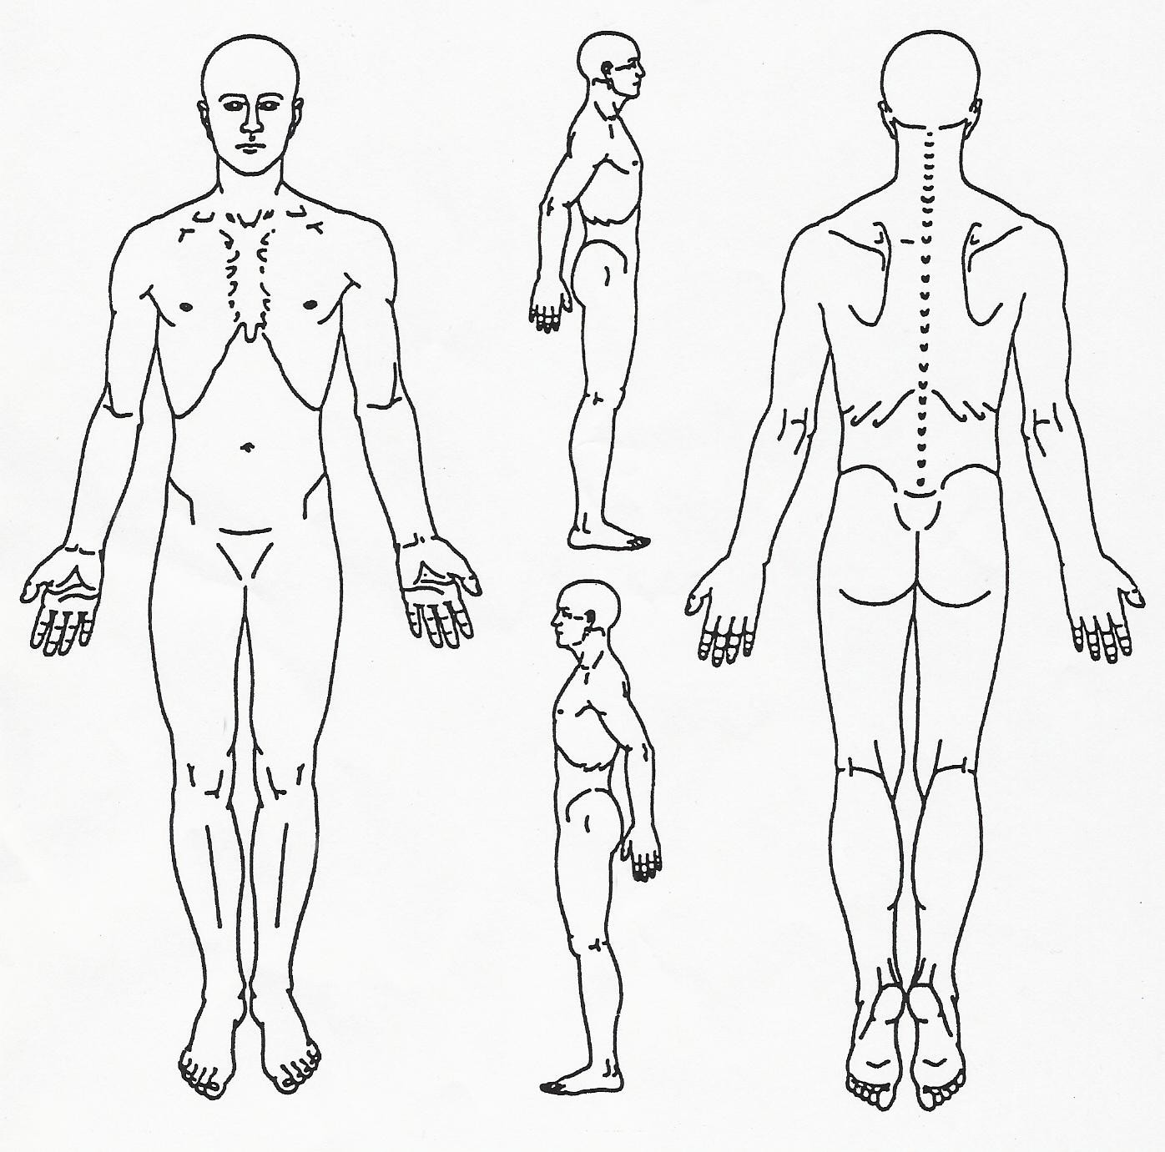

**Pain Diagram**

**Please shade in the area(s) you are experiencing pain**

**Women’s Health**

History of breast implants? No Yes

History of mastectomy? No Yes

If yes, date? ________________________________________

Circle which breast(s): Right Left

Date of last menstrual cycle: ________________________________

Last Pap:

History of a hysterectomy? No Yes

If yes, date? _______________________________________________

History of bone density scan?

Date of most recent bone density scan? _________________________________________

History of Osteoporosis? No Yes

Treatment for Osteoporosis: __________________________________________________

**By signing below, you certify that the included information is accurate and inclusive of all information relevant to your care.**

Patient Signature: __________________________________________Date: _________________

Printed Name: __________________________________________________________________